Math 1303
B
Test #2 – Fall 2010 - Take-home
Yellow Version

Name:
Take-home part is due in class on Monday, October 31. NO late assignments will be accepted.
BOX YOUR ANSWERS

5. Consider the polynomial function 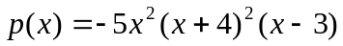
a) Write the leading term and determine the end behavior of the function (use arrow notation)
b) Find the zeros of the polynomial, determine their multiplicity, and state if the graph crosses or bounces at each x-int.
c) Find the y- intercept
x
d) Use this information to sketch a graph of the function.
BOX YOUR ANSWERS. GRAPHS FROM CALCULATORS
WILL RECEIVE NO CREDIT

6. For the rational function 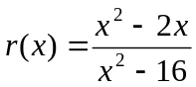
a) Determine the domain and find all the horizontal asymptotes AND vertical asymptotes. SHOW YOUR WORK
b) Find the x- and y-intercepts
x
c) Graph the function (Use test points if needed)
BOX YOUR ANSWERS. YOUR GRAPH MUST SHOW ALL THE
INFORMATION FOUND ABOVE. GRAPHS FROM CALCULATORS
WILL RECEIVE NO CREDIT

7. Complete the square to analyze the quadratic function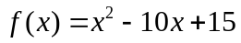. Determine the coordinates of the vertex, the x- and y- intercepts, and draw the graph of the function. You must show ALL your work. GRAPHS FROM CALCULATORS WILL RECEIVE NO CREDIT.
BOX YOUR ANSWERS
x

Extra Credit
Simplify the difference quotient for 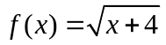

On my honor, I verify that I have neither received any help nor given any information about this exam.

______________________________________

